**Aim: Create a home automation system and control the devices remotely**

Install telepot package

**sudo pip3 install telepot**

**sudo pip install telepot**

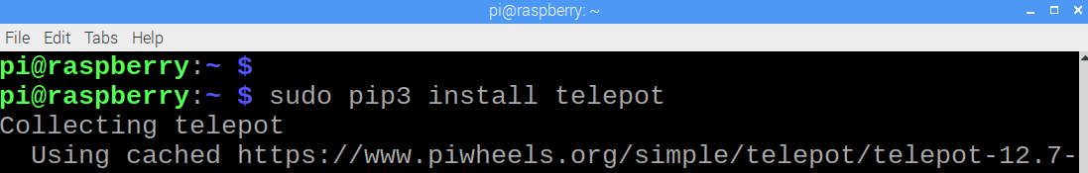

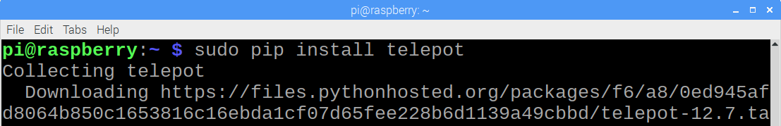

Create a chat bot.

Open telegram and login

<https://web.telegram.org/>

Enter your number and click Next.

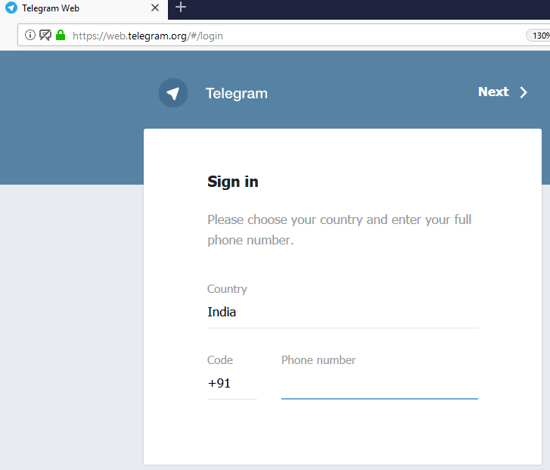

Type BotFather

Select BotFather chat

Click Start

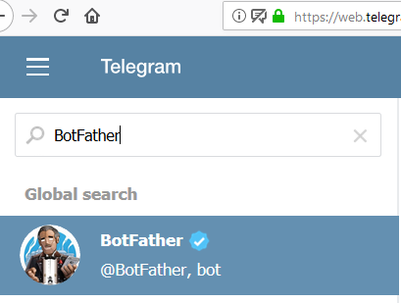

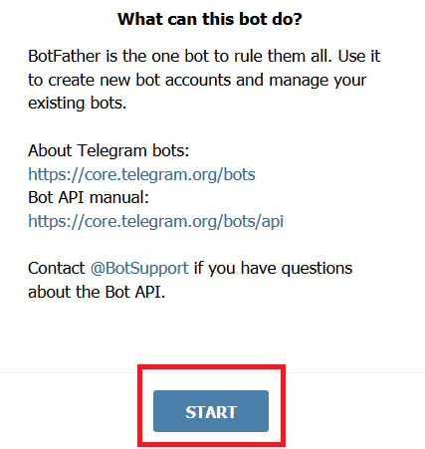

Type /newbot [and press enter]



Enter a unique bot name twice.

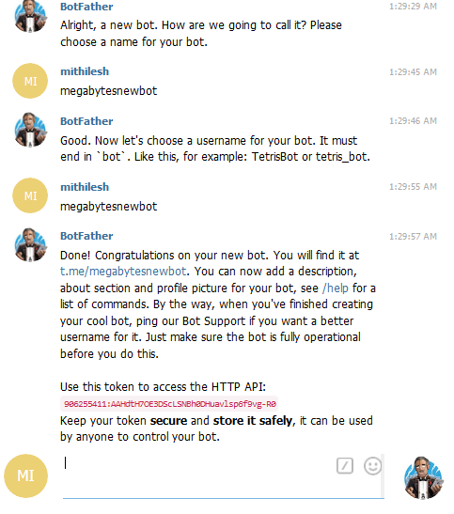

Note HTTP API.

Open IDLE and Write program. Save it as teletest,py

Execute program using IDLE

#telegram prog start

import time

import telepot

import RPi.GPIO as GPIO

from telepot.loop import MessageLoop

GPIO.setmode(GPIO.BCM)

GPIO.setwarnings(False)

GPIO.setup(20, GPIO.OUT)

def handle(msg):

chat_id = msg['chat']['id']

command = msg['text']

print ('Got command: %s' % command)

bot.sendMessage(chat_id,"Command received");

if command == '/on':

print('on')

GPIO.output(20,GPIO.HIGH)

elif command == '/off':

print('off')

GPIO.output(20,GPIO.LOW)

bot = telepot.Bot('HTTP-API')

#Replace HTTP-API with bot HTTP-API

MessageLoop(bot, handle).run_as_thread()

print ('I am listening ...')

while 1:

time.sleep(10)

#Program ends

Execute the programs. Go to Telegram app and type your bot name created earlier (megabytesnewbot) or click on link to open chat.

Click start

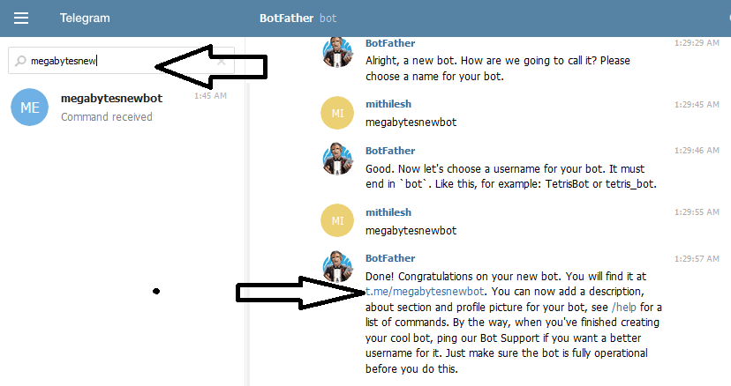

We have connected an LED on GPIO 20 and we will turn on and off this LED with telepot.

